Create a BMI calculator using JavaScript querySelector () and eventListener()

In this hands-on project, we create a simple BMI calculator using JavaScript’s querySelector() and eventListener() functions. If you don’t know what BMI is, please do some research on it.
- Make a copy of the index.html file, name it “BMICalculator.html”, then open BMICalculator in the editor.
- Firstly, we create a simple interface for users to enter two values – height and weight, plus a button “Get BMI” to calculate the BMI value.
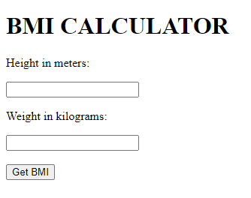

- Type the following code in the <body> section.
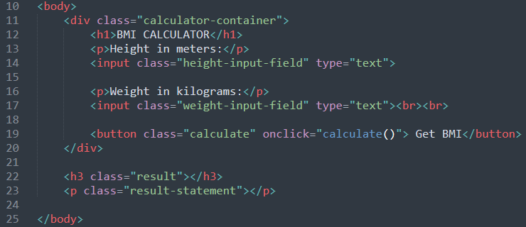
Note we have used HTML class attributes for the 5 elements. The class attribute is often used to point to a class name in a style sheet. It can also be used by JavaScript to access and manipulate elements with a specific class name.
- height-input-field: for accessing data from the height field
- weight-input-field: for accessing data from the weight field
- calculate: for calculate function
- result: for display the BMI result
- result-statement: for display a statement on BMI category
Once the button is clicked, the JavaScript function calculate() should be invoked. The above HTML body section is quite simple. The major task will be done in the JavaScript function.

- Start a <script> </script> block at the bottom of the HTML file, declare a function called “calculate()”.
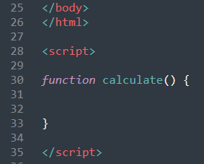
- What should we do first in this function? Yeah, we need to get html elements (and their values) from the DOM objects. Remember the browser creates a Document Object Model (DOM) of the page when a web page is loaded.

We can use document.querySelector() method to select the element. A parameter is needed. The parameter to be selected can be a class name (“.className”), an id(“#idName”) or an element(“elementName”). In our example, the class name attributes can be selected. 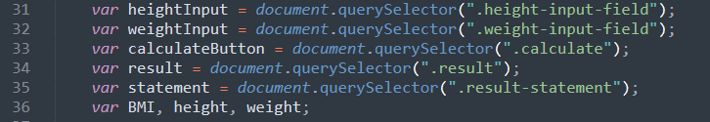
Line 31 – 35 selected the DOM objects according to the 5 class names and assign them with variables. Line 36 declares 3 variables for calculation purposes.

- We need to get the DOM object’s values and calculate the BMI. The formular for BMI is
BMI = weight / (height * height)
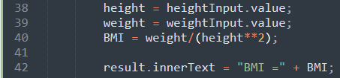
- The next section is to work out the BMI category and assign the category to the statement (a DOM object)’s innerText.
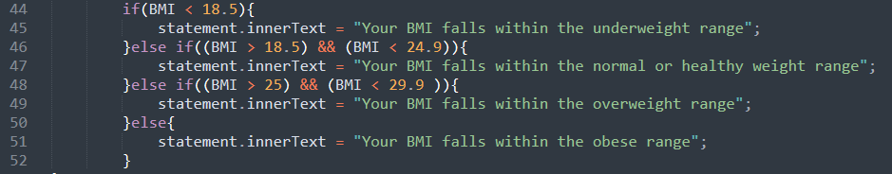

Note: There are a few differences between “innerText” and the “innerHTML”
- The innerText property sets or returns the text content of an element.
- The innerHTML property sets or returns the HTML content (inner HTML) of an element.
- Save the code and test the program with different inputs for a different category.
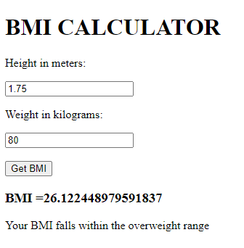
- By now, the application BMI calculator should be done.

Next from 10 – 13, we separate the JavaScript file from the HTML file.

- In the above exercise, we have embedded the JavaScript function in the same HTML file. We can put the JavaScript file as a separate .js file. Separate HTML and JavaScript code can make the code easy to read and easy to maintain.
- In the BMICalculator.html file, comment off all the JavaScript functions. And cut-paste this whole function into another new file, named script.js. Save it in the same folder of BMICalculator.html.

Note, you should not have <script> </script> tag in the .js file.
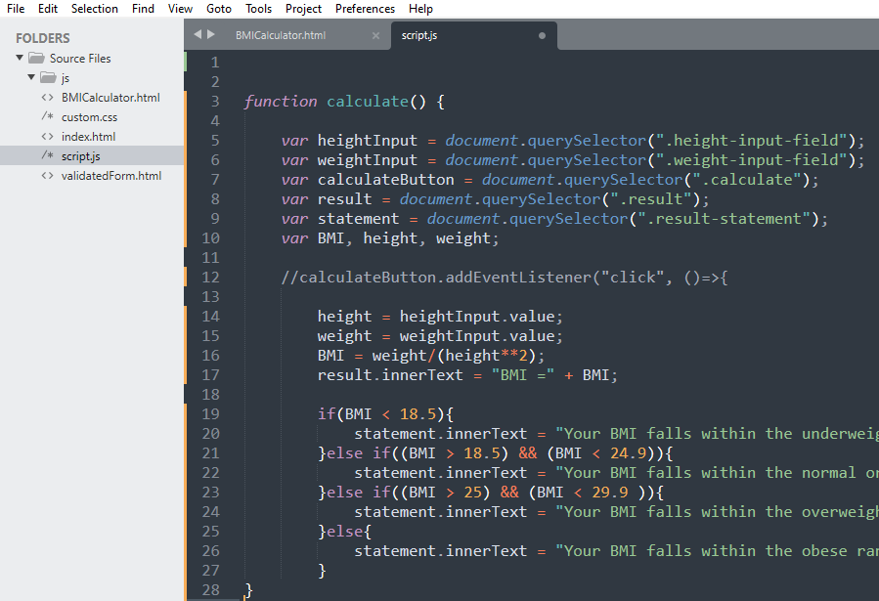

- Add a reference to the JavaScript file in the BMICalculator.html file.
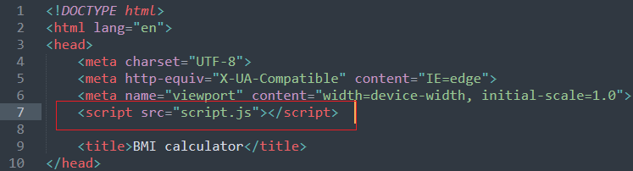
- Save and test the program. It should work the same as it was.

The below steps are for reference only.
- As you can see, JavaScript code is very flexible. In the above practices, we have used a button event onclick() to the button element
<button class="calculate" onclick="calculate()"> Get BMI</button>
Alternatively, we can add an event listener directly to the button and add the associate function.

An event listener is a procedure of function in a computer program that waits for an event to occur. Examples of an event are the user clicking or moving the mouse, pressing a key on the keyboard, or an internal timer or interrupt. The listener is programmed to react to an input or signal by calling the event's handler.

The syntax for addEventListener is:
document.addEventListener(event, function, Capture)

You may explore further in the future.

- That completes the Hands-on Project 2.

